**SVKM’s NMIMS**

**Mukesh Patel School of Technology Management & Engineering**

Program: B Tech/ MBA Tech Artificial Intelligence, B Tech (AI and ML, AI and DS, CSE (DS))

**Course: Machine Learning**

**Experiment No.06**

PART B

|  |  |
| --- | --- |
| SAP ID - 70572300052 | Name: Arushi Pandey |
| Class : STME 2nd year | Batch : 2023-27 |
| Date of Experiment: 06-03-25 | Date of Submission: 11-03-25 |
|  |  |

**B.1 Tasks**

**Task 1**

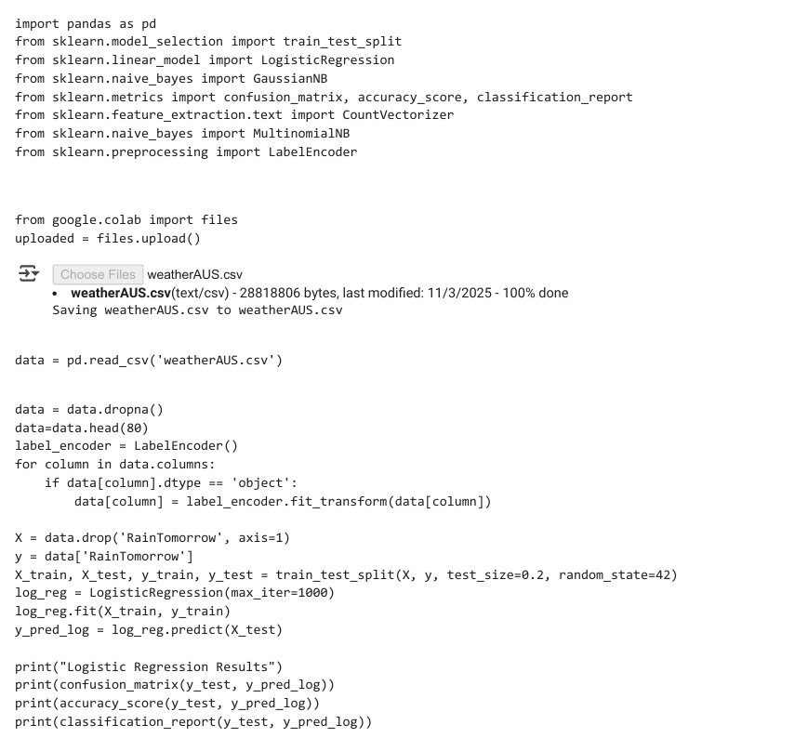

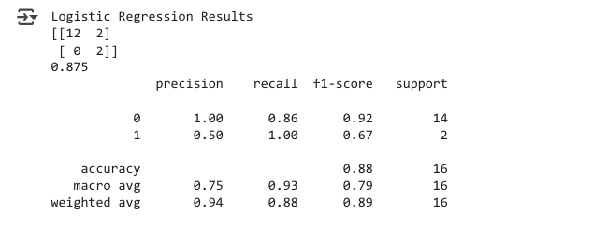

**Task 2**

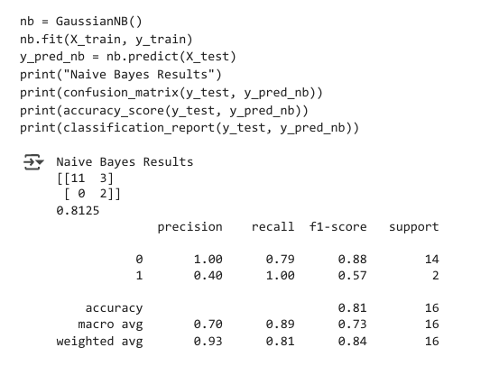

**Task 3**

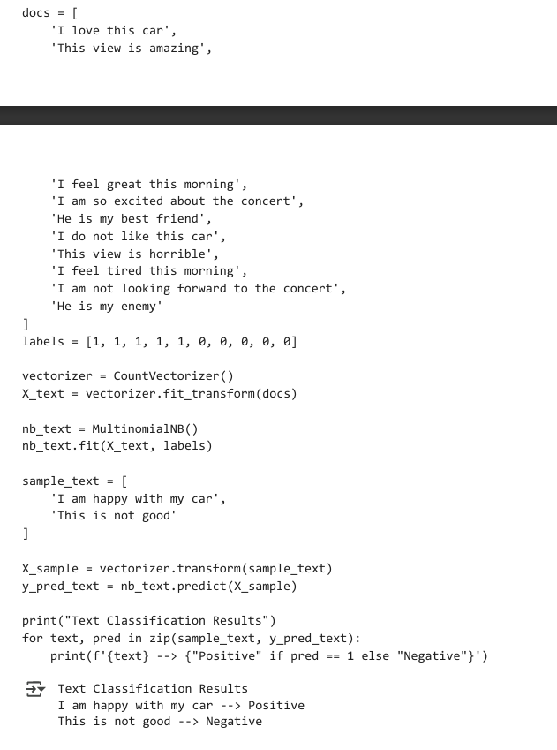

**B.4 Conclusion:**

In this experiment, we successfully implemented Logistic Regression and Naïve Bayes Classifier for classification tasks. We pre-processed the data, applied the models, and evaluated their performance using metrics like Confusion Matrix, Accuracy, Precision, Recall, and F1-Score.

The Logistic Regression model showed high accuracy but faced convergence issues, while the Naïve Bayes Classifier performed efficiently for text classification. We observed that Logistic Regression is suitable for numerical data, whereas Naïve Bayes is effective for text-based data.